|  |
| --- |
| Body of Electric-Assist Bicycle |
| Team 4 |
|  |
| **CCDP 2100** |
| **11/23/2013** |

**Members**

Nick Kamarianakis 100852322

Will Rose 100800974

Neal Traynor 100889248

Douglas Raymond 100904379

Jacob Hawley 100891432

Executive Report

This report provides and analysis of Team 4’s contributions to the enclosed, electric-assist recumbent bicycle. The team focuses on the research and design of five main components of the “body” of the bike. These include: Shape and size, Interior adaptability, Materials for the outer shell and electrical housings, Frame dimensions and a Locking mechanism. All research was conducted using online resources while adhering to the engineering principles listed in the Findings section of the report.

The dimensions of the bike have been decided as 2.78m long by 0.85m wide by 1.20m high. The bike will have a slanted/curved roof to eliminate snow and rain buildup. For interior adaptability, the seat of the bike was carefully designed while focusing mainly on the H-Point and spine curvature of the human body. The seat is designed to maximize comfort and improve posture of the user while still remaining adjustable and accessible for all body types and sizes. The materials for the bike need to be durable and lightweight to provide the safest ride for the user. With this in mind, Glass-Fiber Reinforced Polyester is chosen for the outer shell as it is impact resistant and has a sleek attractive appearance. For the electrical housings Glass-Filled Polycarbonate will be used because of its electrical insulation properties and strength to weight ratio. The wheel base and seat position were analyzed for the frame of the bike. The wheel base is decided as 1.2m to allow the best balance between traction and handling. The seat will be placed at a 7:3 ratio from the back wheel (84cm from back) to maximize power generated by the user. Lastly a locking option was for the bike was researched. It was decided a more compact and lightweight version of the existing car lock can be integrated into the shell of the bike to protect against theft.

In conclusion this report effectively conveys the research and designs for the five major components of the body of the electric-assist bike. Further recommendations for all components discussed include:

* All components of the body must be as lightweight as possible to maximize efficiency and battery life without compromising on functionality.
* All components of the body must be as inexpensive as possible to stay within the budget due to the high cost of other electrical components and the BionX system.

Table of Contents

1. List of Tables
2. List of Figures
3. Nomenclature
4. Introduction
5. Background
6. Findings
   1. Shape and Size
      1. Appearance
      2. Shape
      3. Dimensions
   2. Materials
      1. Electrical Housings
      2. Outer Panels
   3. Frame
      1. Force Distribution
         1. Wheel Placement
         2. Seat Placement
      2. Centre of Mass
   4. Locking Mechanism
      1. Primary Option
      2. Secondary Option
      3. Reccomendations
   5. Interior
      1. Ergonomics
         1. Posture
         2. Reach and Eye Sight
      2. Adjustability
7. Conclusion

References

Glossary

List of Tables

Table Title……………………………………………………….……...Page ##

Table 1: Compressive strengths and flammability rating of polycarbonate 14

Table 2: Rating criteria for UL94 vertical flame test 15

Table 3: Support Parameters Recommendations 23

List of Figures

Figure Title Page ##

Figure 1: Effects of aerodynamic drag on a cyclist 9

Figure 2: Aerorider ™ - White paint modification (Orthogonal view) 10

Figure 3: Aerorider ™ - Red paint modification 10

Figure 4: Aerorider™ - White paint modification (Side view) 10

Figure 5: Sketch of the Vehicle 12

Figure 6: Sketch of the Vehicle used in calculating surface area 12

Figure 7: GoPro™ camera with polycarbonate case 13

Figure 8: Diagram of UL 94 vertical flame test (blue bar is material being tested) 15

Figure 9: Long Wheel Base 18

Figure 10: Short Wheel Bas 18

Figure 11: Seat Placement 19

Figure 12: High Centre of Mass 20

Figure 13: Ideal Frame 21

Figure 14: Mechanism internal side view 22

Figure 15: Mechanism external front view 22

Figure 16: Door placement 23

Figure 17: Common door lock setup 24

Figure 18: Schematic Illustration of Lumbar Support Recommendations 26

Figure 19: Key Locations for Comfort and Adjustability 28

Figure 20: Seated Posture Angles 29

Nomenclature

*˚ -*Degree

*GF -*Glass Filled

*kg* -Kilogram

*m -* Meter

*m2* - Square Meter

*cm* -centimeter

*mm* -Millimeter

*psi -*Pounds per square inch

**1.0 Introduction**

The purpose of this report is to present the Body group’s findings to the client, Kaia Nightingale. Ms. Nightingale’s request was for a design for an electrically-assisted recumbent fully enclosed tricycle, herein referred to as the Vehicle. The Body group’s findings are in the aspects of the Size and Shape of the outer shell, the Materials of the outer shell, the Frame of the Vehicle, the Interior design, and the vehicle’s Locking Mechanism in sections 3.1, 3.2, 3.2, 3.4, 3.5, respectively. In the following sections the group’s findings will be detailed and explained with design recommendations.

**2.0 Background Information**

Ms. Nightingale’s request for an electrically-assisted vehicle is to fill a vacuum in the market for more economically and environmentally friendly vehicles. She has requested a vehicle that can be used on city streets, preferably small enough to occupy bike lanes incorporated in roadway right of ways. Along with size she has also requested that the vehicle be inexpensive and be operable without insurance. To meet the no-insurance-required criterion the Vehicle will have to have speed limitations and so be allowed to travel in bike lanes or shoulders of roadways where delineated bike lanes do not exist. Pollution of the environment has become a major concern as more vehicles enter into service the more pollution they create. The introduction of electric vehicles can offset some of the pollution released by conventional combustion engines. The Vehicle will be electrically-assisted and therefore no greenhouse gas emissions will be added to the environment from use of the Vehicle. An additional benefit of the electrically-assisted vehicle is the ability to commute long distances. The electric assist can increase the output of power from pedaling the vehicle so longer distances can be reached. The Vehicle will be fully enclosed so commuting to work during the winter months will be similar to that of driving a conventional road vehicle. As the Vehicle will be mostly powered by the driver’s pedaling exercise for the driver will be a constant and daily routine. The benefits of daily exercise will be the alleviation of stress from the workplace and a healthier commuter who may or may not have exercised at all.

**3.0 Findings**

**3.1 Shape and Size [Douglas Raymond]**

This section of the report will explain how the shape and size of the vehicle have been decided as well as any developments that have led to making a decision on the final design for the outer frame. *Aerodynamic*s and *efficiency* are the engineering principles used in the development of the shape/size of the *recumbent* vehicle. The research question that was focused on was, “What is the ideal shape and size for an electric assist bicycle?”

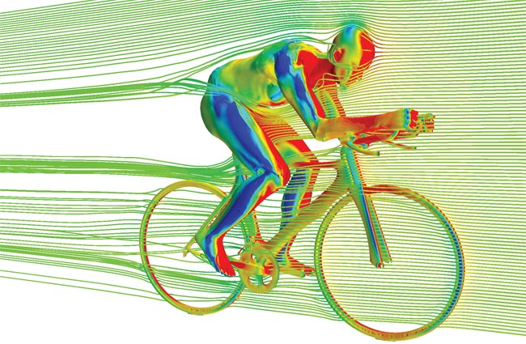

*Figure 1: Effects of aerodynamic drag on a cyclist*

Shape and size entail the appearance, the outer frame and the dimensions of the vehicle. These aspects are significant when designing the vehicle as the vehicle will need to be small enough for a single user to pedal/move while also allowing room for housing accessories, appliances and said user.

* + 1. Appearance

Appearance describes the exterior form of the Vehicle, such as the decals and paint job. The appearance of the Vehicle will be modern and *streamlined* while maintaining an edge. Simple colors and lines will draw the user’s eye to the curves of the vehicle. Different coloured models are pictured below.

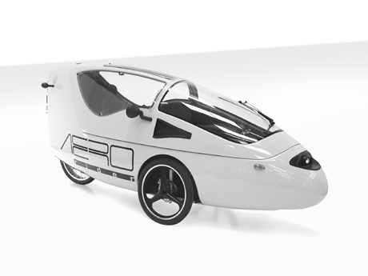

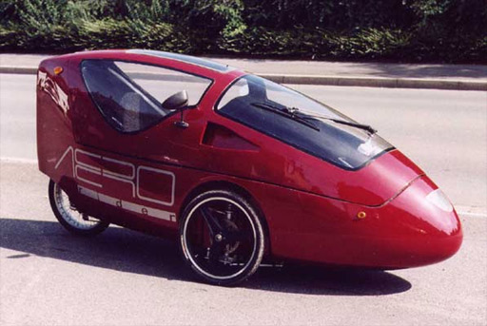  
  
  
  
  
  
*Figure 2: Aerorider ™ - White paint modification*

*Figure 3: Aerorider ™ - Red* Paint modifications

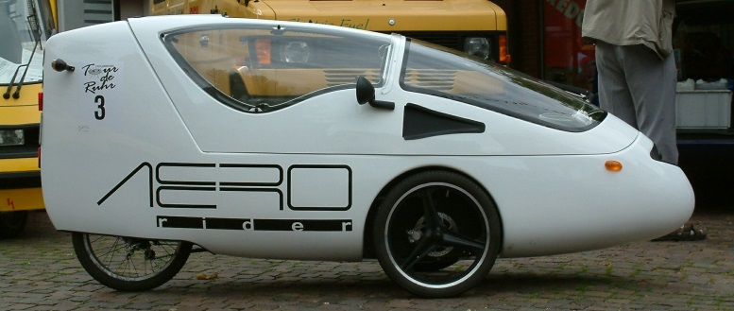

*Figure 4: Aerorider™ - White paint modification (Side view)*

All of the above models have the same basic shape and size; aerodynamic shape and small size allowing for easier maneuverability.

* + 1. Shape

The shape will consider the winter season - and will minimize the snow collection on the roof. Aerodynamics will be carefully considered; making sure the bicycle weight will be *efficient* for all seasons and tasks provided. The model will be shaped similar to that of a raindrop, as the natural shape of a raindrop, travelling at terminal velocity has negligible air resistance, reducing *drag force*, thereby reducing the total effort required to move the vehicle. To reduce the amount of snowfall collecting on the roof of the vehicle a sloped roof will be considered, by doing so, the user does not transport as much excess weight (snow) while pedaling.

Front :( Pi * radius *slant height) +   
Back :( 1.2m*0.85m) + Sides: (2*(0.6m*1.2m)) = 4.2 metres squared

* + 1. Dimensions

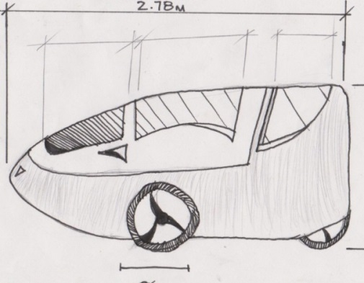The dimensions of the tricycle have been specifically tailored to the size of Canadian bike lanes, enough space has been provided to comfortably fit the user as well as incorporate additional safety features. Dimensions are 2.4m long by 0.85m wide by 1.20m high (based on existing models of recumbent tricycles [3]). Each portion of the shell will be carefully considered as no space can be squandered.

To calculate the cost of materials for the outer frame, surface area will need to be calculated. When calculating surface area a scale drawing was done and the outer frame was broken down into smaller shapes and the sum of the area of the shapes was then calculated.

*Fig. 5 Sketch of “The Vehicle”*

The surface area calculated using Figure 6 is 4.2 meters squared.

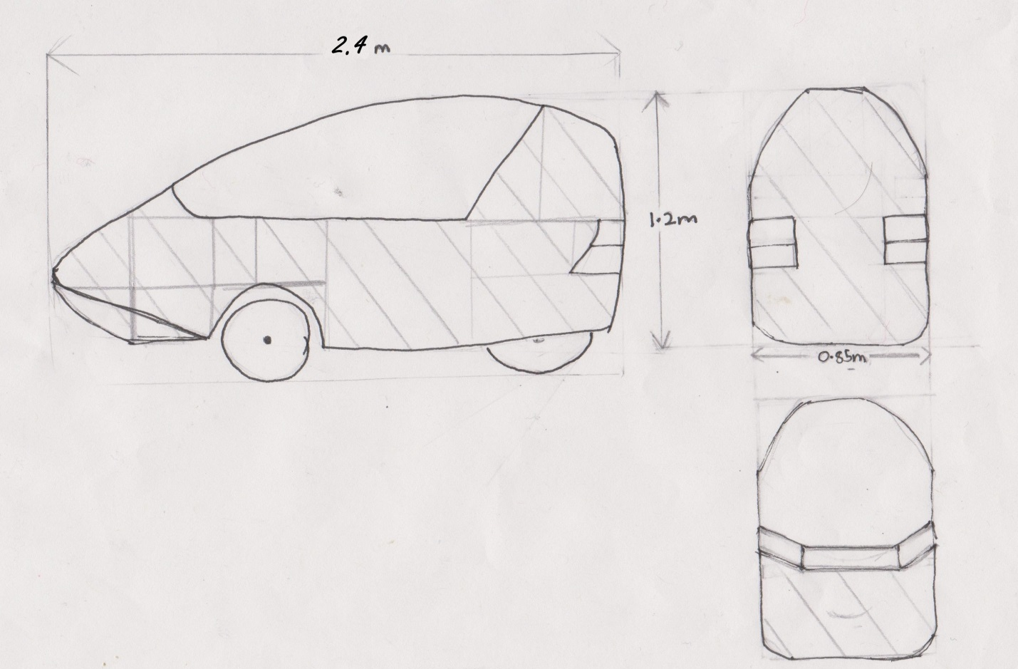

*Figure 6 Sketch of the Vehicle used in calculating surface area*

**3.2 Materials [Nick Kamarianakis]**

This section of the report will cover the materials to be used for the housings of the electrical components within the bike as well as outer “shell”. The engineering principles used when conducting the research were durability, strength to weight ratio and cost effectiveness. These principles were used to answer the question “What is a material that can keep the cyclist safe while still remaining light enough to move”. With these in mind two separate materials were chosen.

* + 1. Electrical Housings

For housing the electrical components a material known as Glass-Filled Polycarbonate [5] has been chosen. For the remainder of the report, Glass-Filled Polycarbonate will be referred to as GFP. GFP has a wide variety of applications, all of which require the material to be durable and lightweight. One example of this is the housing for the High Definition sport camera GoProtm [6] in figure 6.

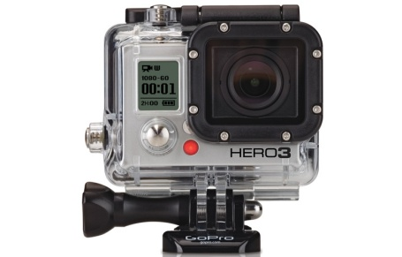

*Figure 7: GoProtm camera with polycarbonate case [7]*

This camera housing protects the delicate electronics inside from all weather conditions as well as any damage caused from high impact sports. The GFP used in this case will be a good choice for housing the electrical components because it is highly impact resistant [5], has good flammability rating [7] and good electrical insulation properties [5]. Table 1 below compares the compressive strengths of GFP depending on how much glass is in the material.

*Table 1: Compressive strengths and flammability rating of polycarbonate [5]*

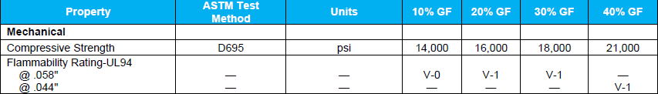

This table shows that an increase in glass percentage increases the compressive strength of the material however as the glass content increases, the *impact resistance* of the material decreases [5]. With this in mind, 20% glass content has been selected as it is most commonly used and provides the best balance of compressive strength and impact resistance. GFP also has a good flammability rating. Table 2 on the following page shows the rating procedure for the UL94 vertical flame test in figure 7.

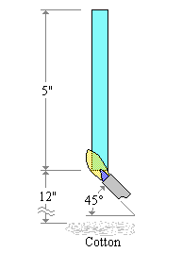

*Figure 8: diagram of UL 94 vertical flame test (blue bar is material being tested) [7]*

*Table 2: Rating criteria for UL94 vertical flame test [7]*

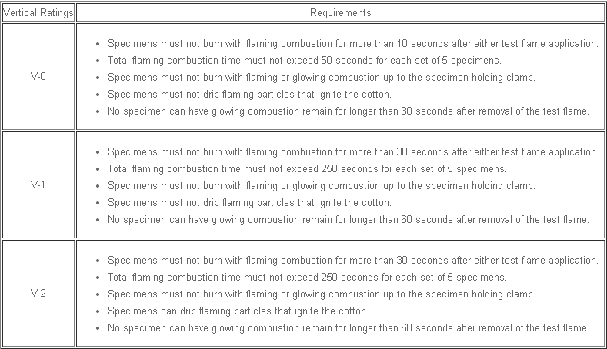

20% GFP falls under V-1 category for the vertical flame test. This means that the material will not drip flaming particles that ignite the cotton underneath it. The material will also not produce a large flame when in the presence of a flame. These properties make 20% GFP ideal because in the event of an accident, the expensive and delicate electrical components will not be damaged, making repairs much cheaper in the long run. There are however two issues that make GFP unsuitable for the outer panels of the enclosed bike: GFP starts clear but will yellow over time with exposure to elements, and GFP cannot be made easily in large intricate designs for outer panels. For these reasons a different material with similar properties will be used for the outer body panels.

* + 1. Outer Panels

For the outer panels, Glass-Fiber Reinforced Polyester will be used. For the remainder of the report Glass-Fiber Reinforced Polyester will be referred to as FRP. Although FRP does not have the resistive properties of GFP, it is still quite durable and lightweight and can be made in large irregular shaped panels [8]. These panels will be able to provide added protection to the cyclist while remaining light enough for the cyclist to power the bike on his/her own. FRP can also be manufactured in virtually any colour to provide a more attractive “sporty” appearance [4], and unlike GFP it will not yellow over time. Another feature of FRP is that it is scratch and graffiti resistant, which will stop any spray paint from bonding to the surface of the panels and reduce the risk or repair costs due to vandalism. FRP is also a relatively inexpensive material. 3.0 mm thick sheets of FRP cost merely 15$ per square meter and weigh 4kg [9] per meter squared. As was mentioned in the “Shape and Size Section” the rough estimate for the total surface of the shell is approximately 4 meters squared. Applying this to the 3.0 mm thick sheets would put the weight of the shell at 16 kilograms, roughly the weight of an average bicycle, and would cost only 60$. This is of course excluding manufacturing costs and indicates the insignificance of the shell on the original budget of 5000$.

In conclusion for the Materials section of the report, 20% Glass Filled Polycarbonate will be used for housing the electrical components because of its high durability and impact resistance. Glass-Fiber Reinforced Polyester will be used for the outer shell of the bike as it provides an attractive appearance and can be made easily into large intricate panels.

**3.3 Frame [Jacob Hawley]**

The frame of the Vehicle must be able to support the weight of the rider, outer shell, and interior components. With all the weight on the frame the wheel placement plays an important role. The frame of the Vehicle must be designed in such a way that the rider is always safe. The Vehicle must not tip or flip over in anyway. Also, the rider must be able to maintain visibility and handling in any situation. To make sure that the Vehicle is the safest that it can be, two engineering principles were examined. The first principle was *force distribution.* Within force distribution two aspects were considered, wheel and seat placement. The second principle *is centre of mass*, which was determined by the height of the seat from the ground.

* + 1. Force distribution

3.3.1.1 Wheel placement

Wheel placement is determined based on the length of the *wheel base*. A wheel base that is too long results in the Vehicle having reduced handling. It will also cause the Vehicle to have a greater *turning radius*. The long wheel base will result in the most unstable Vehicle: the longer the wheel base the easier it is for the bike to tip over or roll. On the positive side, a long wheel base provides a more comfortable and smooth ride since the rider is further away from the wheels. Figure 1 is an example of a recumbent bike with a long wheel base. Although the bike in the figure is not a tricycle it depicts what a long wheel base may look like.

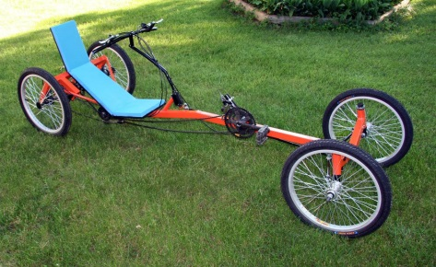

*Figure 9: Long Wheel Base [10]*

The short wheel base leads to a sturdier Vehicle with better handling, and a smaller turning radius. The rider is almost on top of the front wheels with a short wheel base resulting in a bumpier and uncomfortable ride. Also, since the rider is almost on top of the front wheels, the rear wheel will not have enough weight on it. A lack of weight on the rear tire will cause the tire not to gain enough *traction* and spin out, or the rider could flip forward when applying the brakes. Look at figure 10 for an example of a short wheel base.

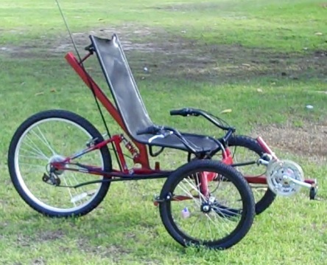

*Figure 10: Short Wheel Base [11]*

Therefore the ideal wheel base is 120 cm [12] to best suit the Vehicle based on the dimensions stated in section 3.1, Shape and Size. This distance is chosen to ensure maximum comfort, handling, and safety.

* + - 1. Seat placement

Where the seat is placed is also a big factor in *force distribution* as the rider may be very heavy and is directly on top of the frame. A seat that is too close to the rear tires can result in the bike flipping backwards while riding. A seat that is too close to the front tires could cause the bike to flip forward when braking. If the seat is too close to either tire the rider could be uncomfortable. If the seat is too close to the rear the bike will be less sturdy and could tip easier. The best seat placement is the ratio of 70/30 measured front tires to back tire [13]: 70 % of the distance towards the front tires if measuring the wheel base starting at the back tire. Based on the wheel base length of 120cm the seat will be 84 cm from the rear tire towards the front. Since the number can vary slightly, and is just the most ideal placement, the seat should be able to slide forward and backwards to tailor to the riders comfort, which is examined more in the Interior, section 3.4. An example of the ideal seat placement can be seen in figure 11.

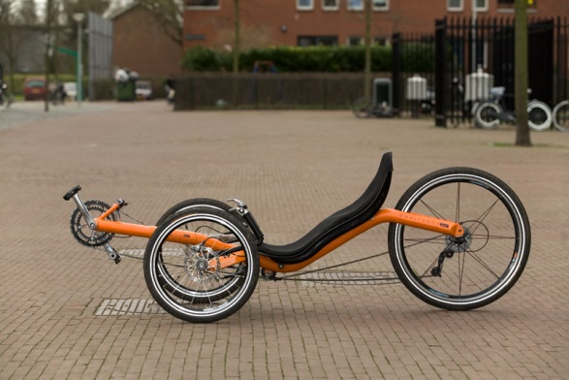

*Figure 11: Seat Placement [14]*

* + 1. Centre of Mass

The *centre of mass* plays a very important role in how sturdy the Vehicle is. If the centre of mass is low enough it is very unlikely the Vehicle will tip, regardless of wheel and seat placement. A centre of mass that is too low can result in a decrease in visibility and safety. Since centre of mass is dependent of the seat height from the ground the frame must be lowered or raised to attain an ideal centre of mass. If the wheel base length and seat placement are not ideal the centre of mass should be below the centre of the tires, but high enough to maintain visibility. Since the wheel base is the ideal length and the seat is in the ideal place the centre of mass can be an equal to the height of the centre of the wheels from the ground and not cause the bike to become unsteady. This can be achieved by putting a bend or curve in the frame within the wheel base. Figure 12 shows a bike with a centre of mass that is higher than the centre of the wheels since the frame does not bend or dip down.

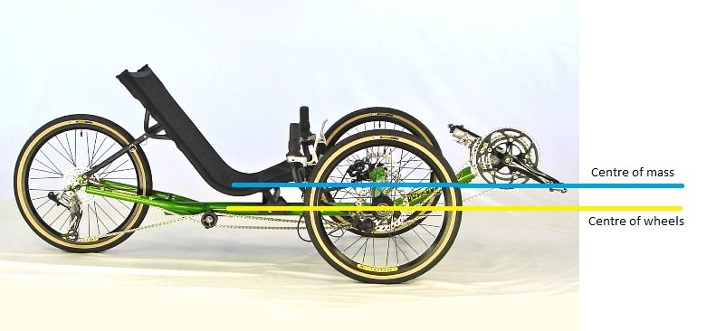

*Figure 12: High Centre of Mass [15]*

The Vehicle is going to have a seat suspension system, this mean that the frame needs to be lowered to ensure the seat is not higher than the centre of the wheels. Lowering the frame by 10 cm should leave room for the suspension, and it will be practical since the average wheel radius, is around 33 cm.

* + 1. Conclusion

The ideal frame for the Vehicle is one that is sturdy, safe, has good visibility and handling. The *force distribution* of the Vehicle relies on both wheel and seat placement. The wheel base length is 120cm long and the seat will be placed 84 cm measured from the rear tire towards the front. The *centre of mass* mostly relies on how high the seat is. Since the wheel and seat placement are ideal the frame will be lowered, allowing space for the suspension and to ensure the seat will be in line with or below the centre of mass of the wheels. With these three placements the bike should be safe and handle with ease. An example of a bike with these conditions can be seen in figure 13.

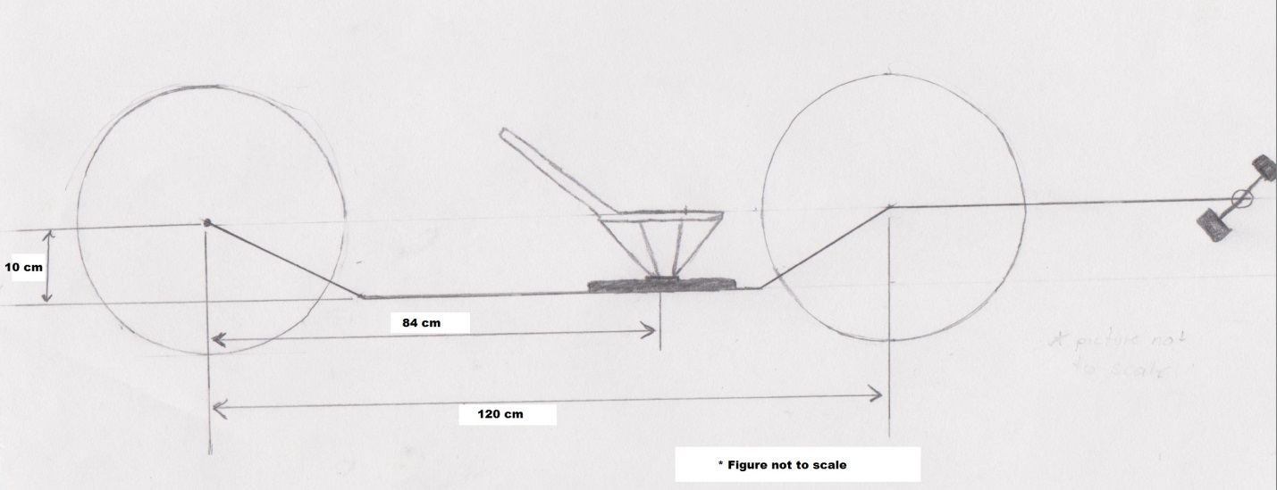

*Figure 13: Ideal Frame*

**3.4: Locking and Security [Neal Traynor]**

This section of the report will cover the design and mechanisms that will be used for the security of the Vehicle. The engineering question asked was "what is the best way to keep the security of the Vehicle as cheap and easy as possible, all the while performing the job that is required?" The engineering parameters used to answer this question were *durability, simplicity,* and *effectiveness.* By applying these three parameters it was determined that a two-tier approach would be sufficient in providing security for the Vehicle. The primary option was modifying the existing car door lock and incorporating it into the door of the recumbent tricycle. This would prevent unwanted access inside the interior of the Vehicle. The secondary option was using a common bike lock to keep the Vehicle attached to a pole or bike rack. This would prevent the Vehicle from being moved or taken away while the user is not there.

3.4.1: Primary Option

The primary option for security of the Vehicle was chosen to be a car door lock incorporated into the door of our Vehicle. This is the best option for preventing unwanted entry to the inside of the Vehicle because it encompasses all three of the engineering parameters defined earlier, and it will make the Vehicle look overall more aesthetically pleasing. The widespread use of the device would make it cheap and easy to acquire the needed number of units, and it would also mean that the product used in the Vehicle would be well tested for strength and effectiveness. A specific mechanism that was found was US Patent number 5 494 321[16](see figures 14 and 15). This mechanism is good for our needs because it was designed to be more compact and have fewer parts than the conventional locking

Figure 14: This is the side view of the internal workings of the mechanism

Figure 15: This is a front view of the mechanism.

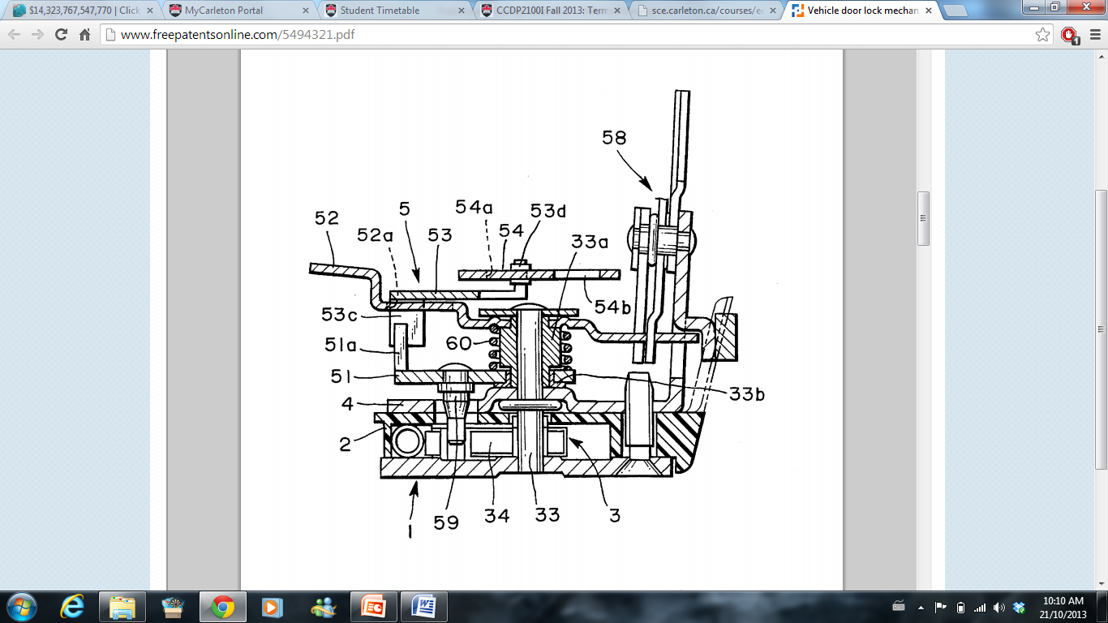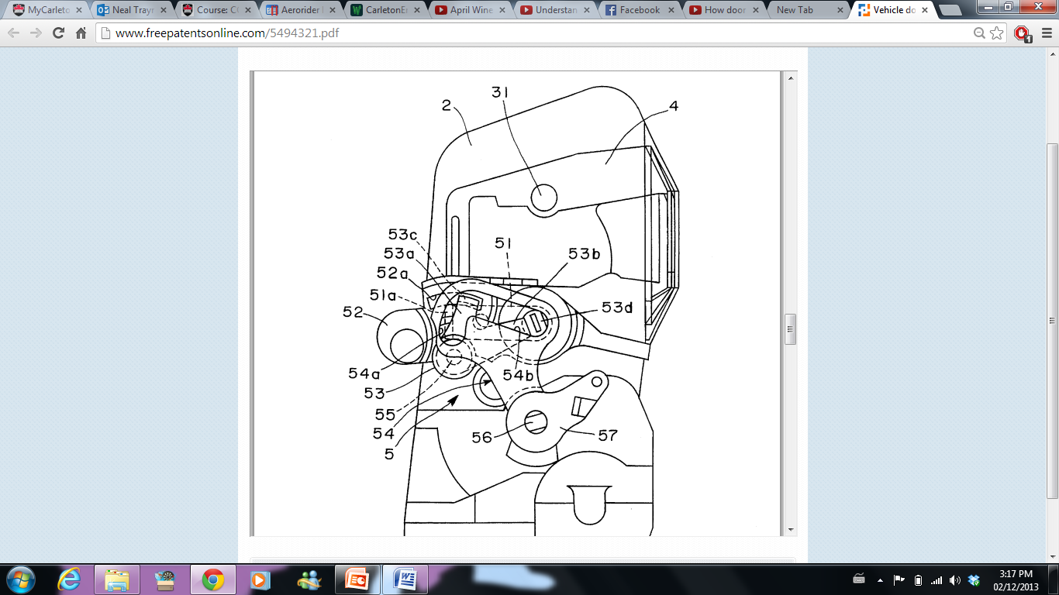

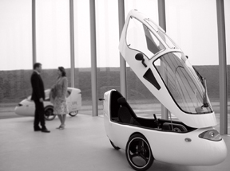mechanism[16]. Figure 14 shows the side view of the internal parts of this mechanism, while figure 15 shows the front view of the mechanism. The car door lock consists of two main parts: The female part and the male part[18]. The male part is usually just a simple metal bar or hook, which would latch onto the female part. The locking mechanism inside the female part would then keep the two parts attached. As a result, having one part on the door and the other part on the frame of the vehicle would keep the door locked when the two parts are attached and the mechanism is functional. In the design used in our Vehicle, figures 14 and 15 show the female part, which will be attached to the frame of the vehicle. By turning the key, part 33 will twist, which will in turn rotate part 51, which will move part 34. Due to the unique door design of our Vehicle, much of the bulk of a traditional car door lock will be able to be eliminated. Figure 17 shows the complete mechanism of the traditional lock save the male part. The male part of the lock would be on the door itself, and the female part will be on the frame. The exact placement would be behind the user's head, so at very back of the vehicle at the top where the door meets the frame of the Vehicle. As a result of these modifications, our design will eliminate most of the metal connection wirings that connect the locking mechanism to the door handle and manual lock lever. Another benefit of this is the bulk of the weight of the mechanism will be over the frame at all times, which will not interfere with Jacob's work on the force distribution of the Vehicle.

Figure 16: This is what the door on the Vehicle will look like.

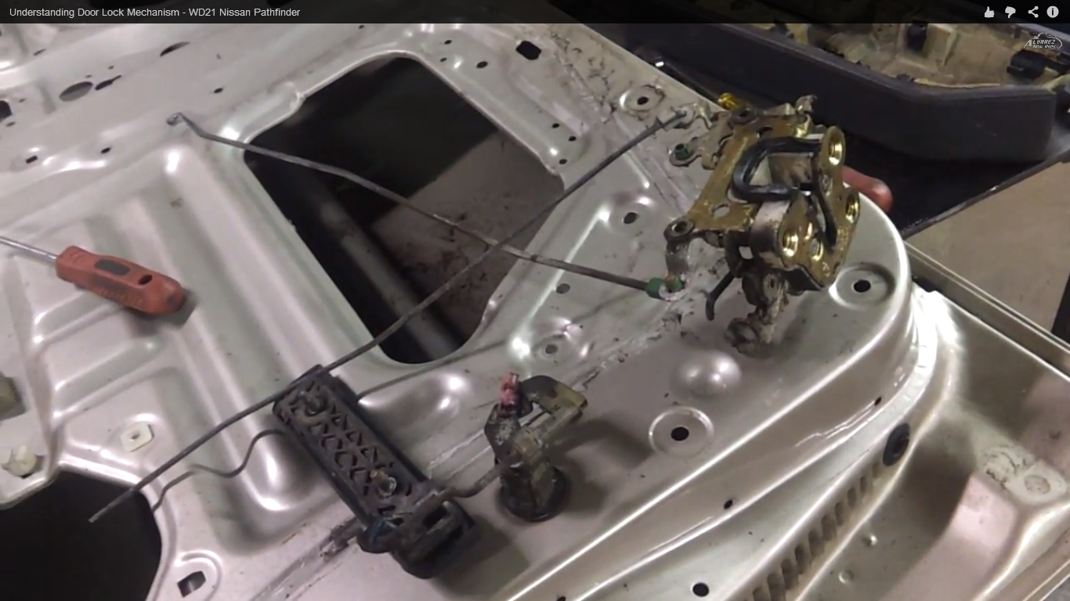

Figure 17: This is the complete locking mechanism for a Nissan PathFinder[17]. Many of the metal wirings can be eliminated due to the design being centralized in a small area.

**3.4.2:** Secondary Option

The secondary option for the security of this Vehicle will be to use a standard bike lock and attach it to the back wheel of the Vehicle which is exposed. This will prevent the Vehicle from being wheeled or carried away. Due to the extreme light weight of the Vehicle, it is very possible that a group of friends could carry it away, or that one person could wheel it away like a wheelbarrow. The main problem with this option is the lack of availability of places to lock the Vehicle to. Until the Vehicle becomes widespread, many cities will not be willing to install bike racks on the side of the road specifically for the Vehicle which we are designing. As a result, this would hinder on the sale of the Vehicle because a less number of people would be willing to buy it if it comes with the "baggage" of needing to attach it to a bike rack or pole which might not be available.

**3.4.3:** Recommendation

The Recommendations for the security and locking mechanisms of the Vehicle are to use a Vehicle door lock for prevention of unwanted entry into the interior of the Vehicle. A bicycle lock will then be used as a secondary option to prevent the vehicle being moved or taken while the user is away. In this way the bicycle will have the best security possible while adhering to the three engineering parameters described earlier.

Figure 1: This is the side view of the internal parts of the mechanism.

3.5 **Interior [Will Rose]**

This section of the report will explain how the design and development of the interior will be accomplished. Considerations for the Interior are the ergonomics and the adjustability of functions therein.

* + 1. Ergonomics

*Ergonomics* is important because it will allow for the best design for a comfortable drive for the commuter and increase the enjoyment of the drive. This section describes the components that have been developed to provide ergonomic comfort to the Vehicle’s drivers; that is, posture, and eye sight and reach.

* + - 1. Posture

How the driver sits while driving the vehicle is important to keep that driver within his/her own comfort level. An irritable drive due to lack of comfort could cause a dangerous driving experience because of lack of attentiveness to the road. Also, poor posture could lead to lower back injuries in cases of repetitive and long term exposure to that posture [19]. Maintaining *lumbar support* is crucial for the driver’s comfort.  Figure 1 shows areas of the *lumbar region* that need to be considered. To support the lumbar area the driver’s seat cushions are to be developed to provide recommended shapes and forms to fit the driver’s own distinct shape. Table 3 lists recommended values. The seat cushion should have a *prominence* within 15mm to 20mm. This will allow the cushion to form within the area and shape of one’s lower back providing support to the lower back region. The curvature of the cushion prominence will have a radius of 300mm to mimic the curvature of a human’s spine curvature. These recommendations will not be adjustable and so will be fixed, as shown in Table 1, and so must be able to meet the average shape of the average human.

*Figure 18: Schematic Illustration of Lumbar Support Recommendations (dimensions in mm). [20]*

Another crucial location for considering a comfortable drive is the location of the *H-point*. How the driver sits in relation to the H-point will determine how he orients his lower back with the seat and reach of his legs. The H-point is used to determine where in the seat the driver’s buttocks is placed. This allows for accurate mapping of the seat cushion positions which placed poorly can lead to driver discomfort; see Figure 18 and Table 3.

Table 3: Support Parameters Recommendations [20]

|  |  |
| --- | --- |
| Parameter | Recommendation |
| Lumbar Support (Fixed) |  |
| * Vertical Design | Locate apex 200–250 mm above depressed seat surface, or  105–155 mm above H-point along back line. Mean preferred height is 150 mm above the H-point. |
| * Prominence | Support should protrude 15 to 20 mm in front of backrest  plane (see Figure 1), yielding a lumbar support prominence measure of 15 to 20 mm. |
| * Radius | The 20-mm support should have a depressed-contour,  convex radius of about 300 mm. |
| * Sacral Relief | Adequate relief should be provided below the lumbar support for the sitter’s buttocks. |
| Lumbar Support (Adjustable) |  |
| * Vertical position | Apex should be adjustable between 100 and 200 mm above the H-point along back line. |
| * Prominence | Prominence should be adjustable between 0 and 30 mm. |
| * Radius | Radius should be adjustable between 250 and 400 mm. If only a prominence adjustment is provided, higher |
| Knee Angle | Included angle between leg and thigh should be less than 135°. Mean preferred angle is 122 degrees. |
| Trunk/Thigh Angle | Angle formed by the knee, hip, and shoulder joints should be larger than 90°. Mean preferred angle is about 105 |
| Back Angle | Angle relative to the vertical of line from hip joint to shoulder joint should be between 10–30°. Mean preferred angle is 28 degrees. Mean preferred angle of line from hip to eye is about 10 degrees. |

* + - 1. Reach and Eye Sight

Being able to reach the pedals comfortably without straining oneself ensures a safe enjoyable drive. As stated above the H-point determines how much length of the leg is available to reach the pedals based on position in the seat itself. Reaching with one’s feet is not the only concern. Being able to reach the steering wheel without strain is important for the comfort of the driver and his control over the Vehicle. However, the need to reach other accessories within the interior means that they should be located within eye sight. *Peripheral vision* is an important factor for reaching other accessories without taking one’s eyes off the road. Checking mirrors should also be included within easy movement of the head to ensure accurate knowledge of upcoming road conditions and surroundings.

* + 1. Adjustability

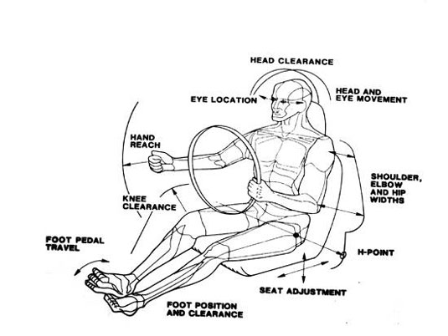Not every driver of our Vehicle will have the same shape, size, and unique tastes to comfort. Figure 19 illustrates possible locations for adjustable functions within the interior of the Vehicle. However, due to limitations of space and quantity of functions in the interior, not every possibility shown in Figure 19 will be applicable. In the preceding section reach was talked about as an important criterion for control of the Vehicle and comfort. Now, reach will be further developed to include adjustable parameters.

*Figure 19: Key Locations for Comfort and Adjustability [21]*

The Human body can be modelled as a system of linkages [20, p. 47] as shown in Figure 20. This allows for the mapping of the human body in relation to a seated posture. The most important angles for comfort are the back, trunk/thigh, and knee angles [20, p.48]. Knowing where the most important locations are, the design of the seat can be allowed to adjust at these locations for the driver chosen comfort. Recommended functions to be allowed to adjust and move are the seat position in relation to the pedals and the seat backrest in relation to a 90 degree angle. Allowing the seat to be adjustable such that it can be moved further away or closer to the pedals depending on the user will change the knee angle. This will allow the driver to reach the pedals more comfortably, without strain, or in the rare cases without the aid of wooden blocks attached to their feet. As our Vehicle is primarily operated with pedal-power, being able to reach the pedals is of critical importance. Seat translations should be of the magnitude of 150mm to 200mm [20, p.52]. This will allow the driver to maintain suggested knee angle orientations shown in Table 1.

*Figure 20: Seated Posture Angles. A: Back, B: Trunk/Thigh, C: Knee, D: Ankle, E: Upper arm, F; Elbow. [20]*

The location of the seat backrest is the other adjustable function chosen to optimize the interior and suit individual comfort. The adjustment of the back rest affects the back angle, one of the critical angles of the seated posture and also the reach of the arms. Allowing for the back rest to adjust up to 20 degrees [2, p.53] is crucial for driver comfort and for reaching the steering wheel of the Vehicle. With the knee angle and back angle being adjustable the back angle will be adjusted coincidentally because of the model of human linkages shown in Figure 3. This will ensure seated posture comfort at the H-Point location.

**4.0 Conclusion**

The dimensions of the Vehicle will be 2.40m long by 0.85m wide, and 1.2m tall which makes the Vehicle small enough for a bike lane. The material selected will be glass-fibre reinforced polymer which is strong enough and light enough to be durable for all-season driving and resistant to road collisions. The frame of the Vehicle will have the wheels located at a 1.2m width to allow for the best balance and traction and the seat in relation to those wheels will be 0.84m from the rear wheel, which will maximize power output by the user. The interior will arranged so that the comfort of the driver is maintained and adjustable so that comfort can be had by all sizes of potential users. The locking mechanisms of the Vehicle will be such that a light-weight car lock can be integrated into the Vehicle.

References

[1] James Thomas. (July 29, 2013). Cycling 360 media by Victor Jimenez [Online]. Available: <http://www.cycling360media.com/wp-content/uploads/2012/10/Adams_STAR-CCM1_650.jpg>

[2] Matt Kelly. (July 16, 2009) Aerorider: The ultimate single-seat hybrid by Matt Kelly[Online] Available:  
<http://www.examiner.com/article/aerorider-the-ultimate-single-seat-hybrid>

[3] Jeroen Haringman (August 2,2007) Test drive Aerorider[Online]  
http://www.solarwebsite.nl/en/2007/08/proefrit-aerorider/

[4] Unknown.(December 22, 2010) Handbuch für Elektrofahrräder & Pedelecs[Online] <http://www.nielsfries.de/literatur/pedelec/handbuch-fur-elektrofahrrader-pedelecs/>

[5] Plastics International (2013) *Zelux (Glass Filled Polycarbonate)* [Online] Available: http://www.plasticsintl.com/datasheets/Polycarbonate_40_GF.pdf

[6] Gopro. (2013) *Hero3 Replacement Housing* [Online] Available: http://gopro.com/camera-accessories/replacement-housing

[7] UL IDES (2013) *UL 94 Flame Rating* [Online] Available: http://www.ides.com/property_descriptions/UL94.asp

[8] Gilham P. (07/01/2010) *Polyester vs. Polycarbonate Materials* [Online] Available: http://sensigraphics.blogspot.ca/2010/01/polyester-vs-polycarbonate-materials.html

[9] Gao R. (2013) *Fiberglass Reinfoced Polester Sheets* [Online] Available: http://www.alibaba.com/productgs/489981610/Fiberglass_reinforced_polyester_sheets.html

[10] Atomic Zombie Extreme. (2010, June 1). New Street Fighter Recumbent Quad Cycle [Online]. Available: http:// www.blogspot.com

[11] Mac. (2011, April 04). New recumbent trike for 82 year old Mom & more – Atomic Zombie builders gallery [Online]. Available: http://atomic-zombie-extreme-machines.blogspot.ca

[12] Unknown. (2010, May 05). Frequently Asked Questions About Recumbent Bicycles [Online]. Available: http:// http://www.recumbents.com/faq.asp

[13] R. Horwitz. (2002, June 06). Build Your Own Recumbent Trike [Online]. Available: http:// http://www.ihpva.org

[14] Radical Brad. (2009, July 21). Warrior Racing Trike Build [Online]. Available: http://www.forum.atomiczombie.com

[15] A. Pirogov. Recumbent Bike Trikes and Tandems [Online]. Available: http://www.recumbentbikesdenver.com

[16] Hiroshi Ishihara, Yoshinobu Ogura, "Vehicle Door lock mechanism", US Patent 5 494 321, Feb 27 1996

[17] Understanding Door Lock Mechanism - WD21 Nissan Pathfinder, *youtube,* <http://www.youtube.com/watch?v=8NK8zcZJif8> (Accessed: November 26th, 2013)

[18]How door lock of a car works, *youtube,* <http://www.youtube.com/watch?v=v3iUZ-UmbOQ>, (Accessed: November 25th, 2013)

[19] J. Robinson, *Good Posture Habits*, [Online] Available: http://www.bigbackpain.com/posture.html

[20] ] M. P. Reed, “Survey of Auto Seat Design Recommendations for Improved Comfort,” Univ. Michigan, 2000. Available: mreed.umtri.umich.edu

[21] Dr. S. Karmarkar. *Basic Ergonomics in Automotive design.* [Online] Available: http://www.dsource.in/course/ergonomics/auto-ergo/introduction/introduction.html

Glossary

*Aerodynamics*: The properties of moving air, and esp. of the interaction between the air and solid

*Centre of mass:* A single point where the mass is equal in all directions

*Compressive Strength:* the resistance of a material to breaking under compression

*Drag force*: refers to forces which act on a solid object in the direction opposite to the relative motion of the body.

*Durability:* Ability to withstand wear, pressure or damage

*Efficiency*: Achieving maximum productivity with minimum wasted effort or expense

*Ergonomics*: the study of the relationship between the driver and the Vehicle

*Force Distribution:* How the Vehicle is affected by the weight of the outer shell, interior . components, and the driver

*H-point*: The H-point is a location on the Human body, located at the hips

*Impact Resistance:* the ability of a material to absorb energy and plastically deform without . . . . . fracturing

*Lumbar Support*: Lower back region

*Peripheral Vision:* Side view when eyes are looking ahead.

*Prominence*: Maximum deflection of curvature of lower spine, measured from the straight angle of the back

*Recumbent*: Lying down, especially in a position of comfort or rest; reclining

*Streamlined:* Design or provide with a form that presents very little resistance to a flow of air or . water, increasing speed and ease of movement of bodies moving through it

*Traction:* The grip of the tire on the road

*Turning Radius:* Diameter of the smallest circle the Vehicle can make

*Wheel Base:* The distance from the centre of the rear tire to the centre of the front tires